Shubham Paudel and Dinesh Bhattarai

Southern institute of technology  11 copper beech avenue

**Documentation of end users help.**

# What is easy appointment?

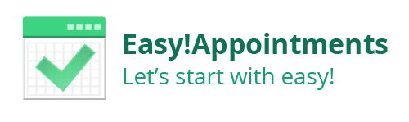

Easy appointments are a highly customizable web application that allows customers to book appointments with you via web. Questions frequently asked while using easy appointments.

# How to go to back end section?

# What should I do if I lose my password?

# How to add appointment?

# How to add customers?

# How to add services?

# How to add users?

# How to change the company details?

# How to change time and date formats?

# How to enable customer notifications?

# How to enable re captcha?

# How to edit personal information’s?

# How to change password?

# How to add break on working day?

# How to know the version of easy appointments?

# How to delete any customer from the appointments?

# How to delete any service?

# How to delete user?

# How to add any unavailable day?

# How to add new admin?

# How to log out?

* **How to go to back end section?**

Firstly, you must check if your easy appointment is running or not. If its running, then the picture shown below should appear.

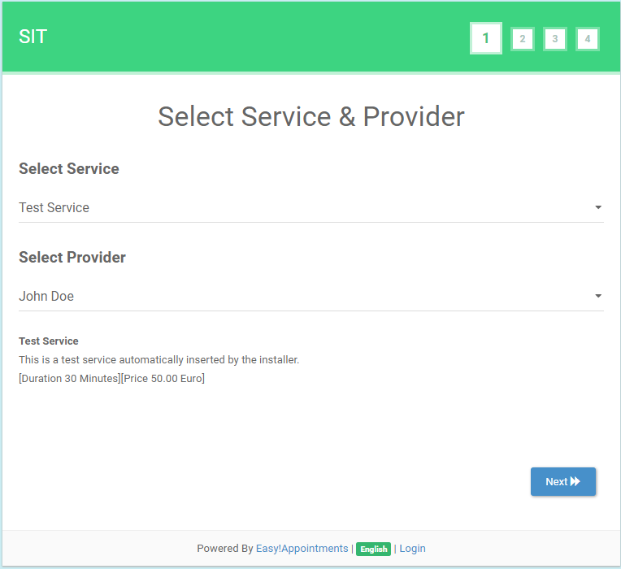

At the end of the page there is a login button you need to click on that button.



After that a login page will appear.

Note: you should provide your user name and password which you have provided while setting up your easy appointment account.

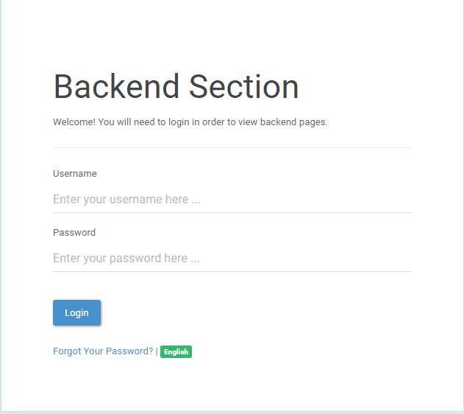

* **What should I do if I lose my password ?**

Go to forget password at the bottom of the page.

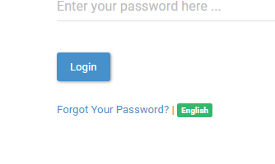

Provide your username and email and click re generate password.

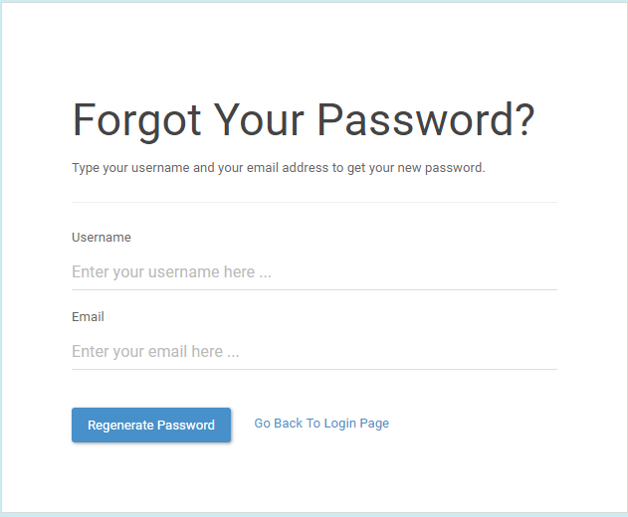

Then the system will send you a verification to your mail. Click on verification and change the password.

When you have logged in you should reach the following page shown in the picture below.

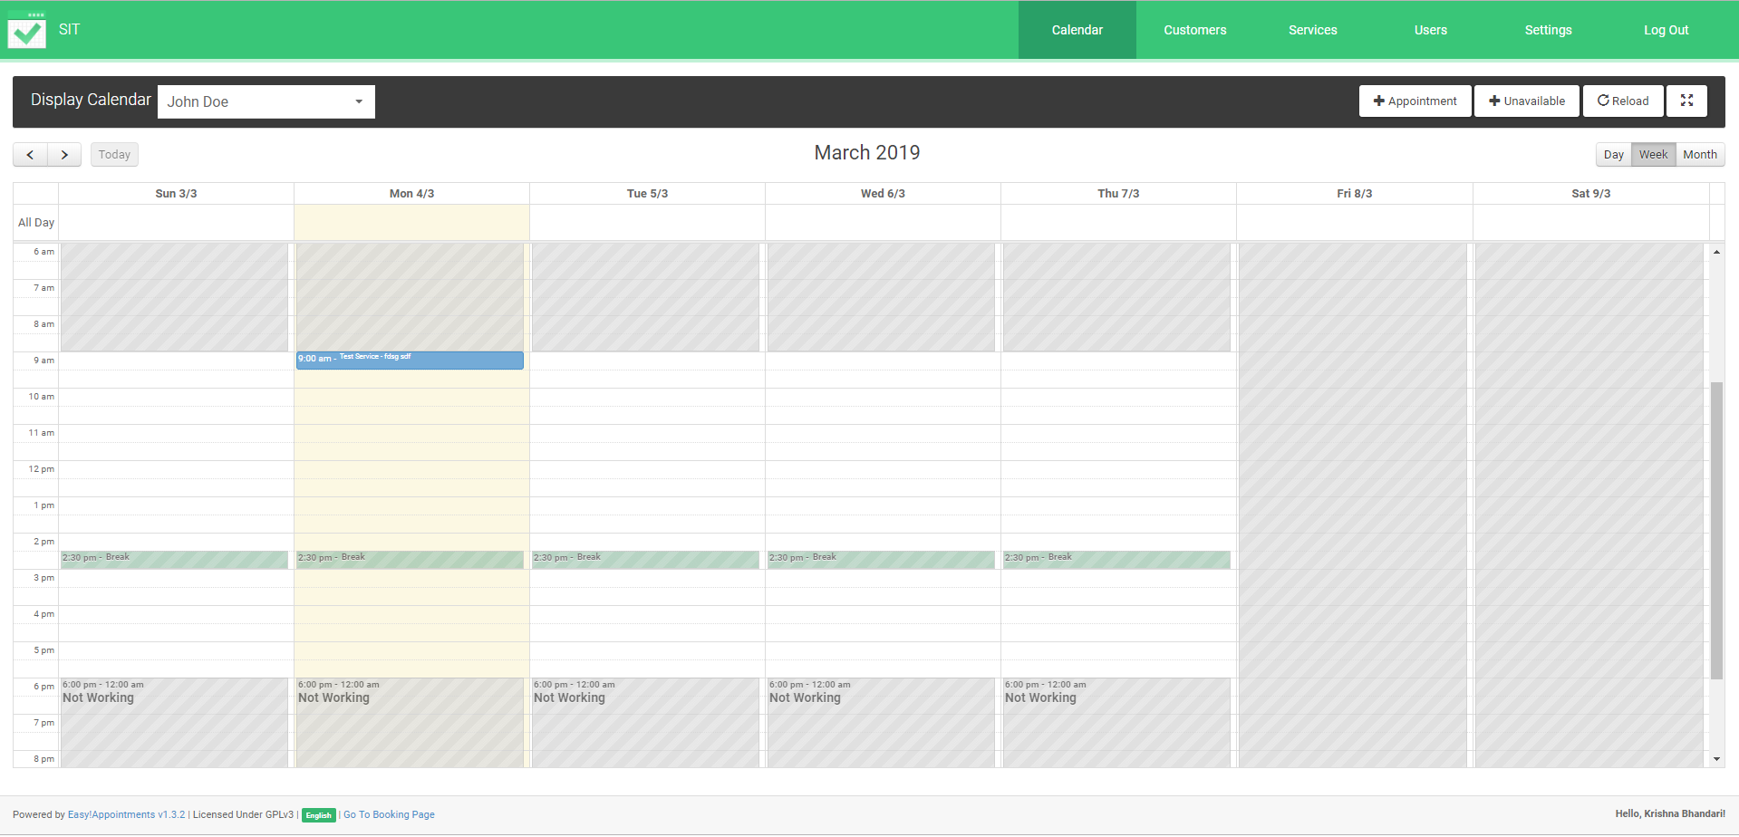

* **How to add appointment?**

For adding appointment there is a button shows add appointment in calendar section. click on that button.

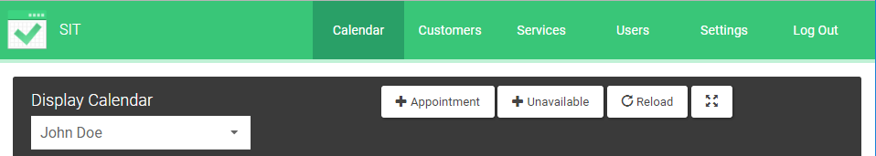

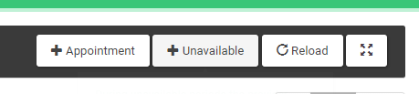

After clicking on the button, a popup will appear where you must fill all the details required and save it.

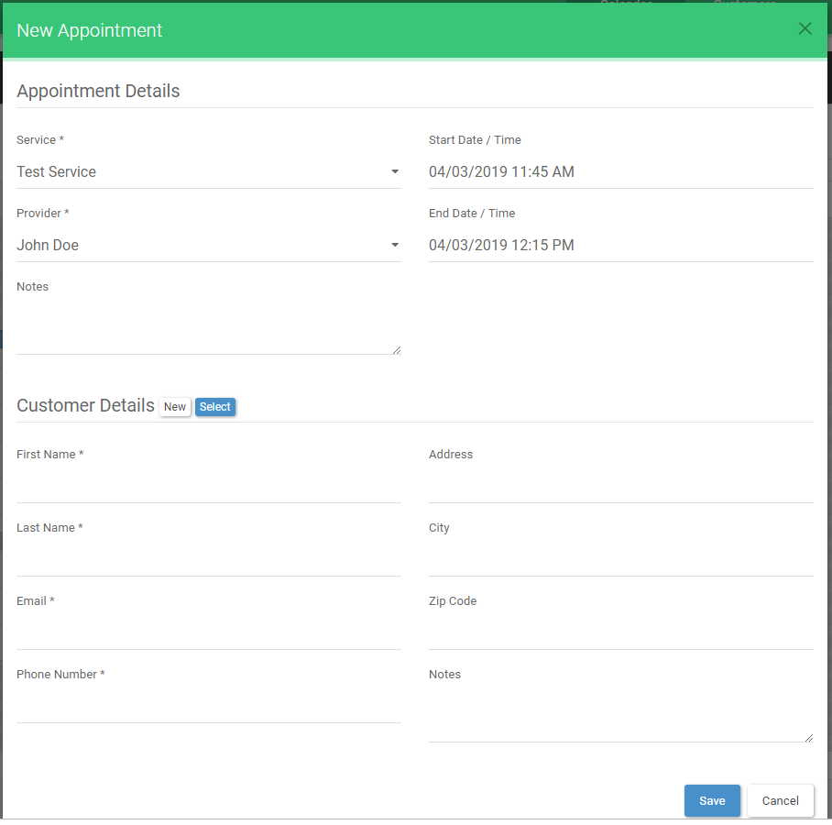

Then your booked appointment will appear on the calendar.

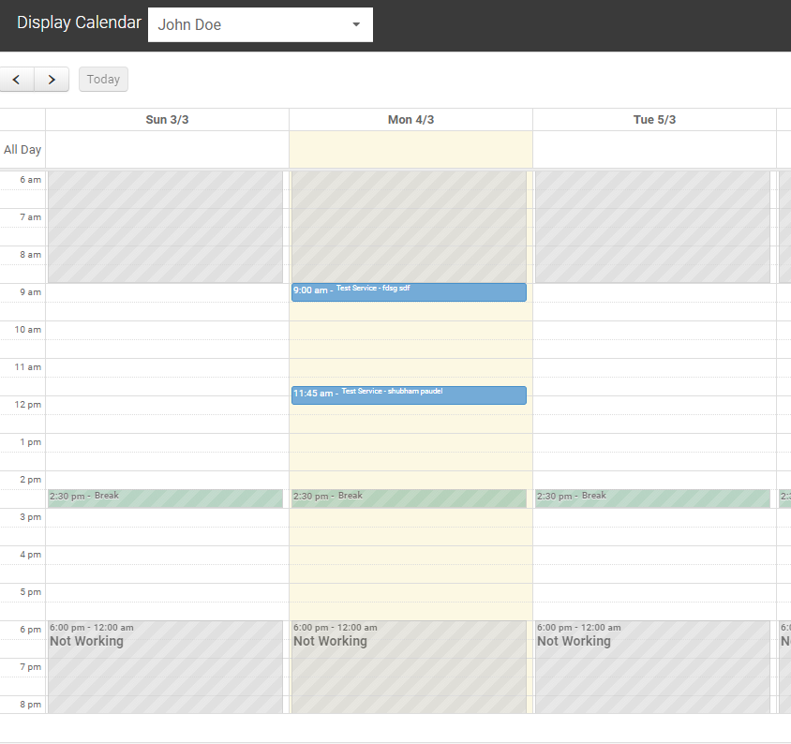

# How to add customers?

Go to customers on top menu bar

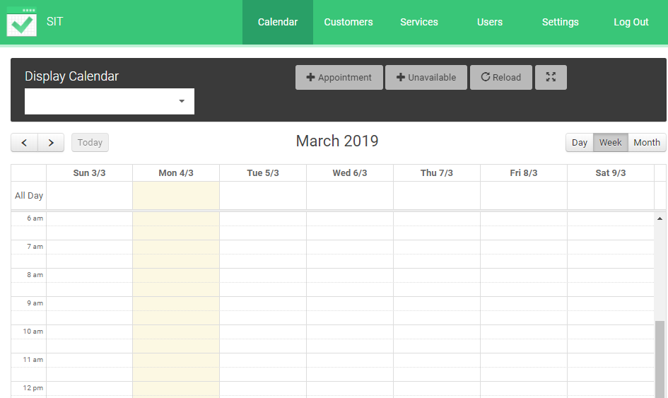

Now click on the add button on the page and fill in the information’s and save it.

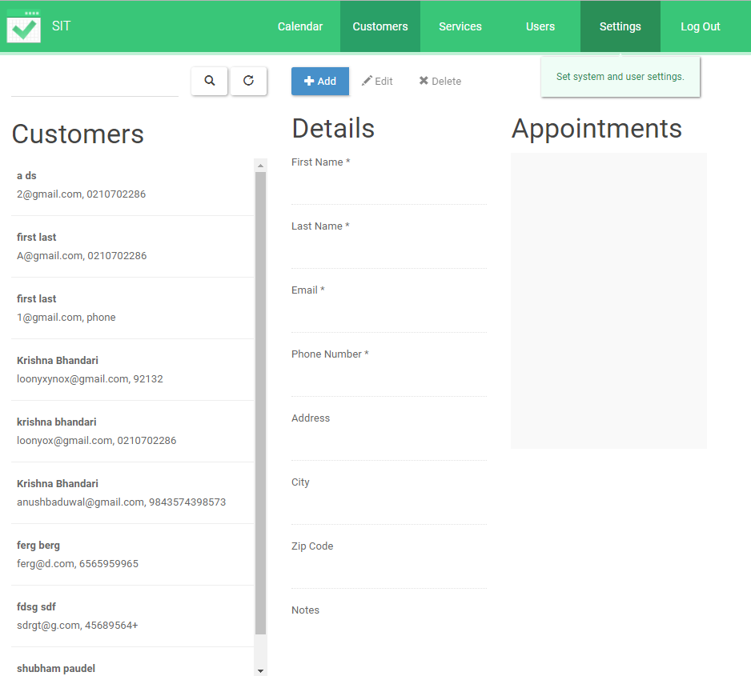

# How to add services?

Go to the menu bar and click on services.

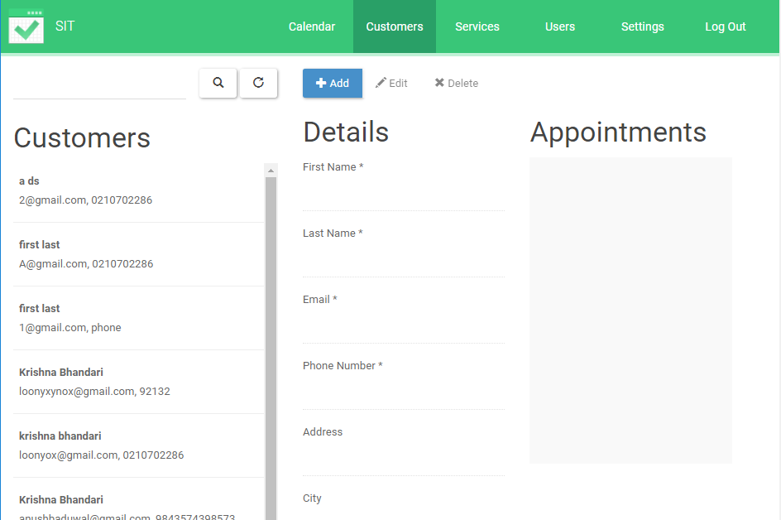

Now click on add on the page. And fill the required information’s and save it.

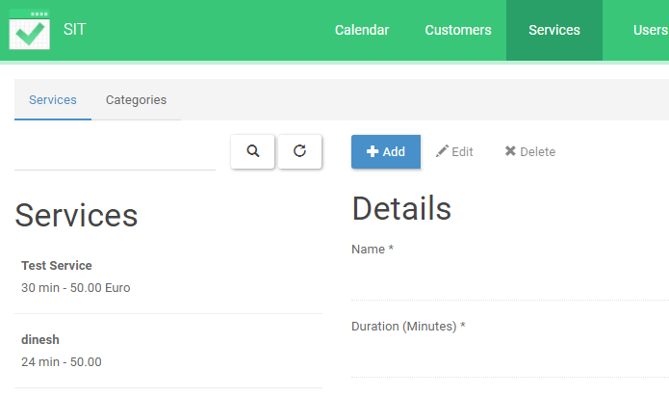

# How to add users?

Click on users on main menu.

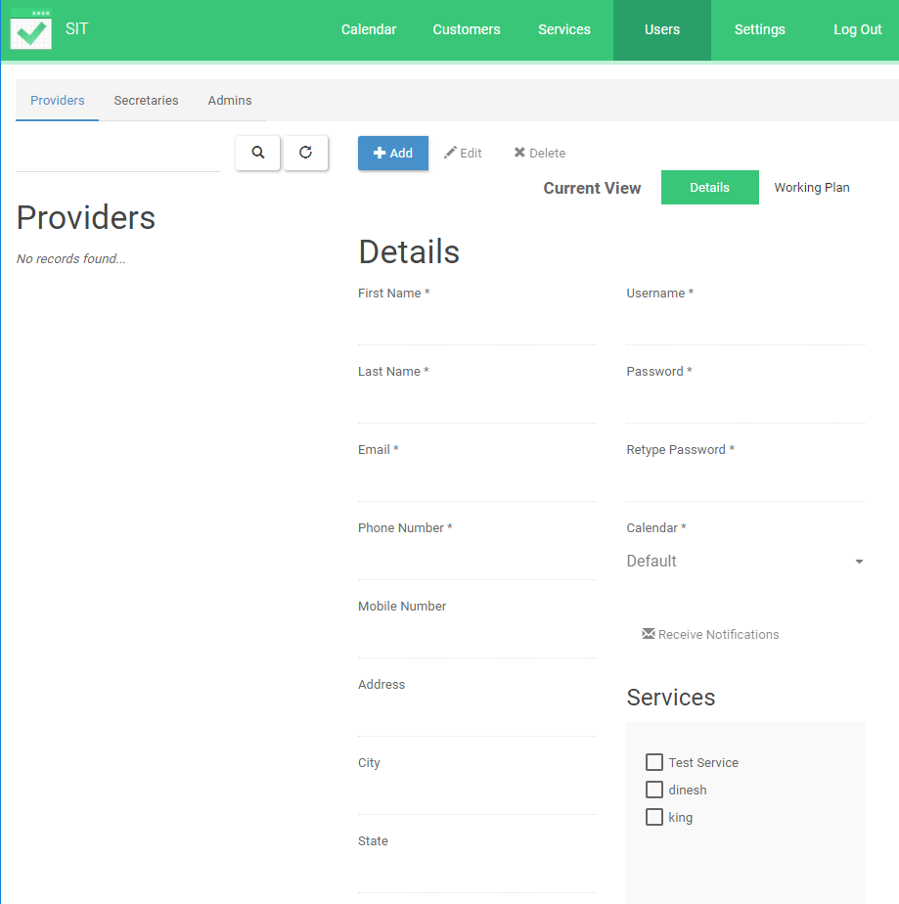

No click on add and fill the required information and save information’s.

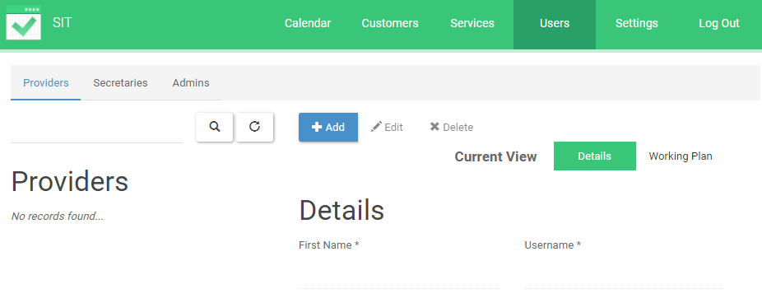

# How to change company details?

Go to settings from the menu.

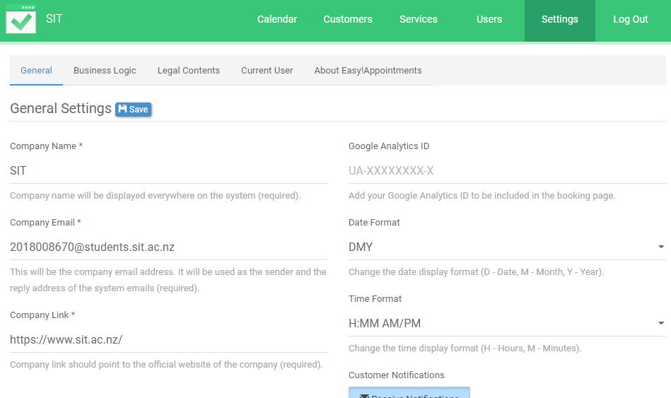

Now click on the settings below general settings change the details and save it.

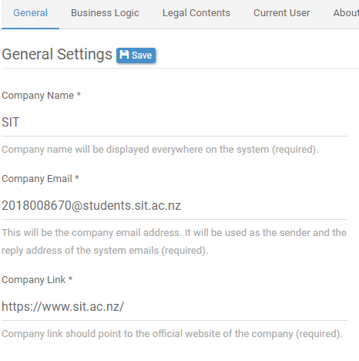

# How to change format of date and time?

Go to setting section. Click on date and time format.

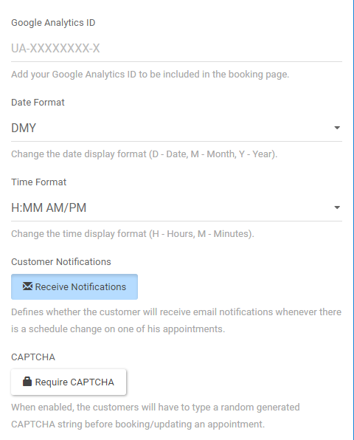

A drop-down menu appears and change the format same with the time.

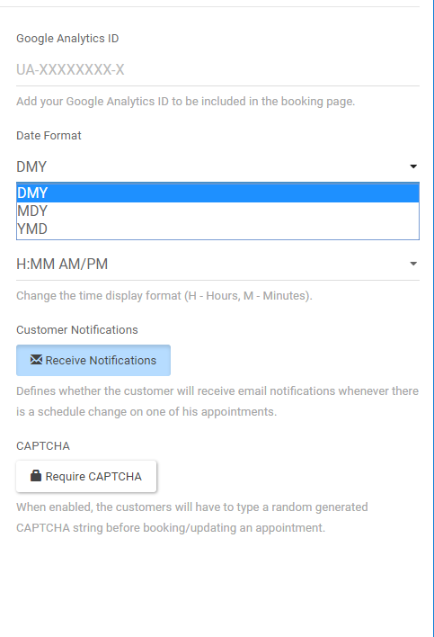

# How to enable customers notifications?

Go to settings and click on receive notifications. And now you will receive notifications

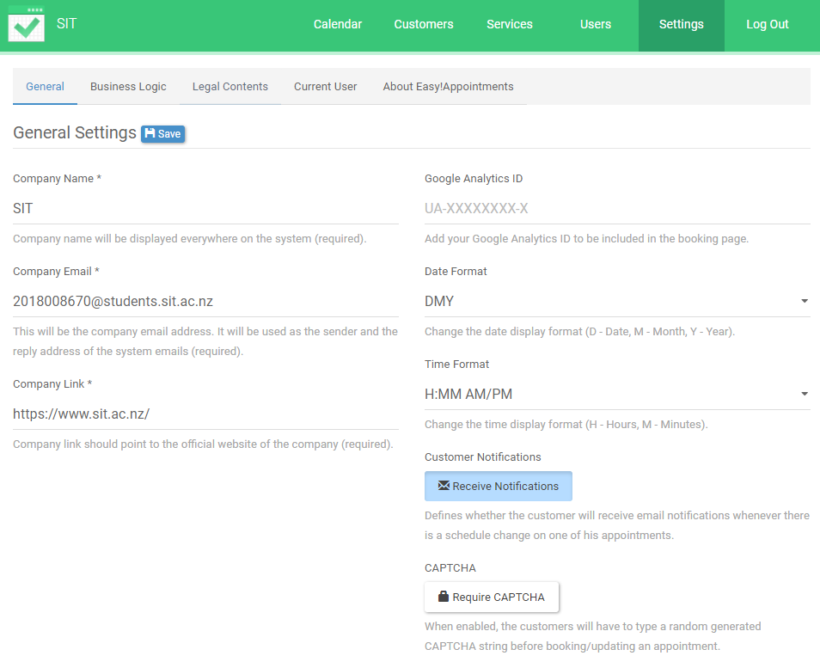

# How to enable re-captcha?

Go to settings and click on require CAPTCHA button on the end of the page and enable it.

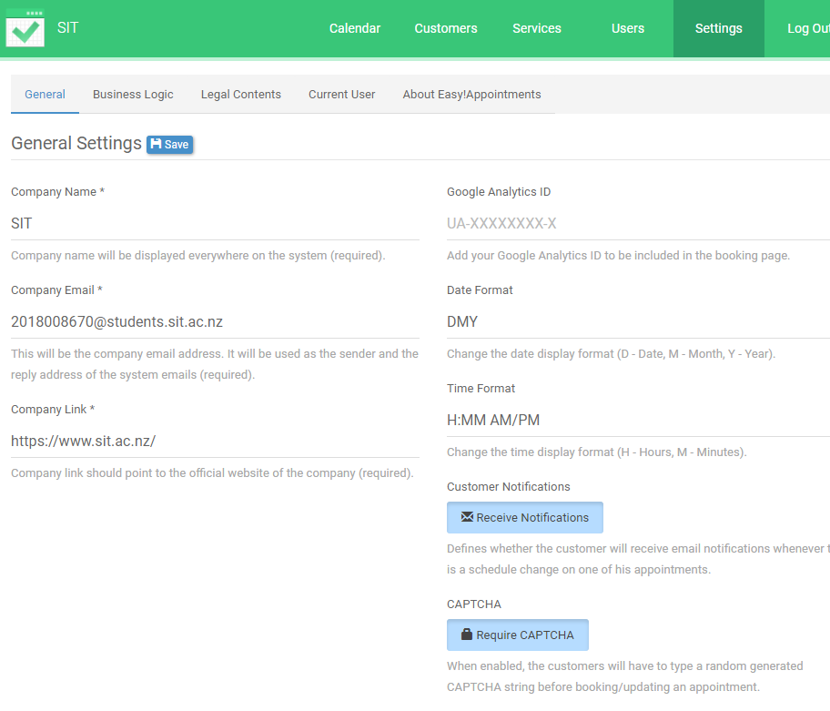

# How to edit personal information’s?

Go to current user in settings.

Edit the informations.

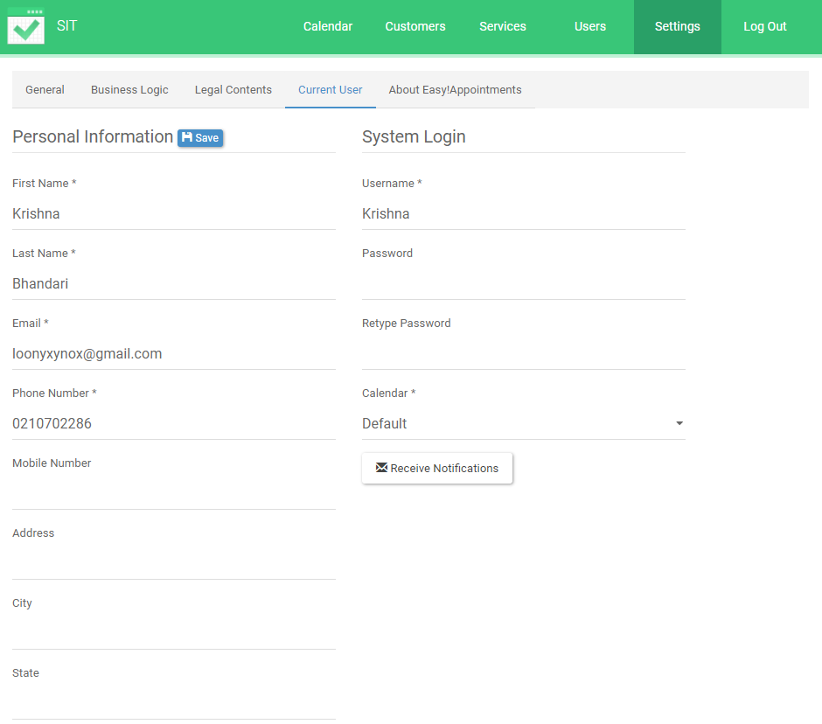

# How to change the password?

Go to current user under settings.

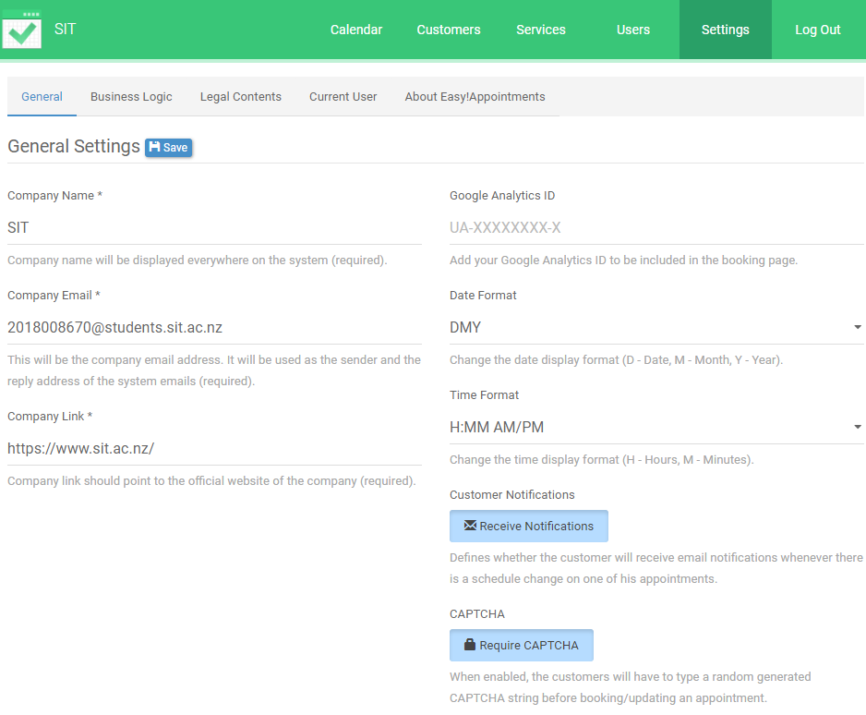

Type new password on the password section and save it

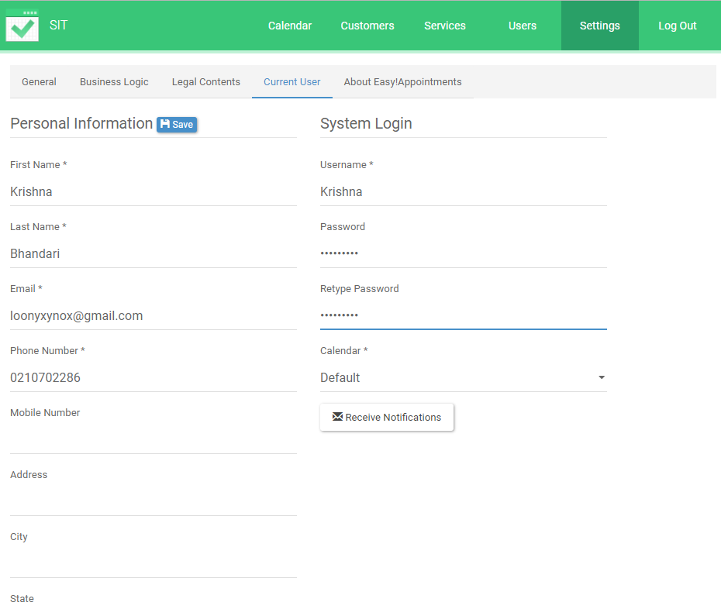

# How to add break on working day?

Go to business logic under settings

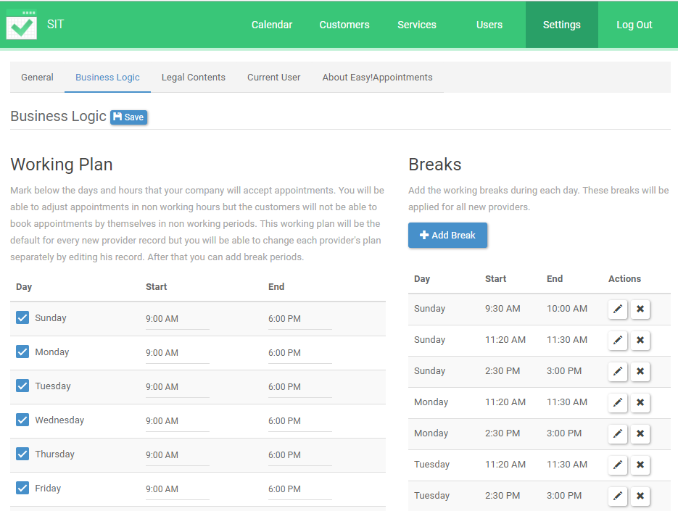

Then click on add break on Breaks.



Then select any days and add break as per needed.

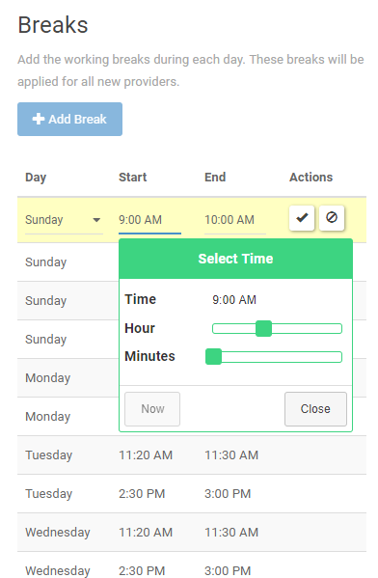

# How to know the version of easy appointments?

Go to about easy appointments under settings.

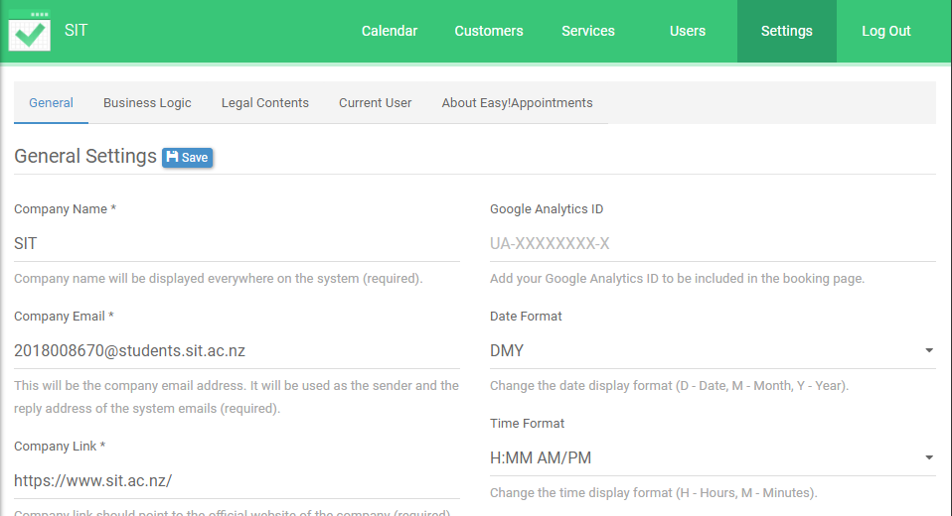

You will find the version under easy appointments

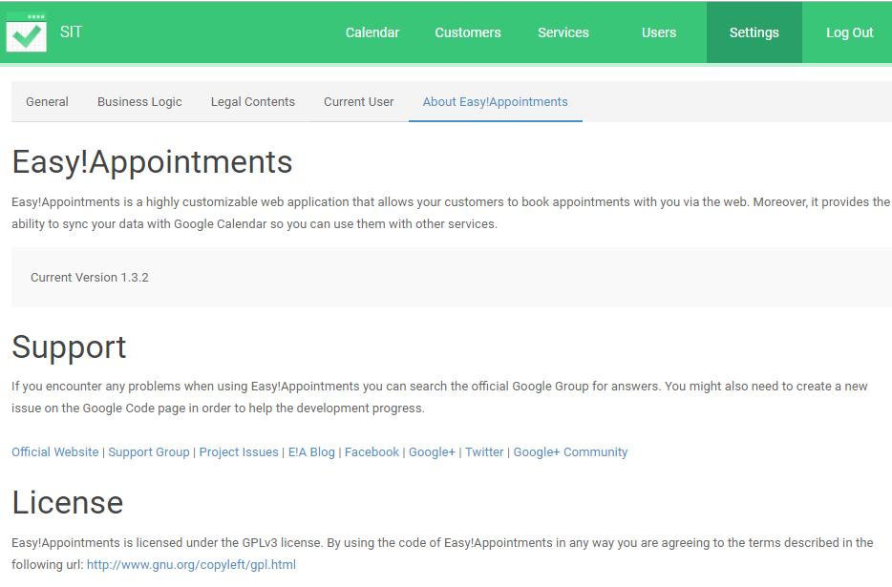

# How to delete any customer from the appointments?

Go to customers on navigation menu.

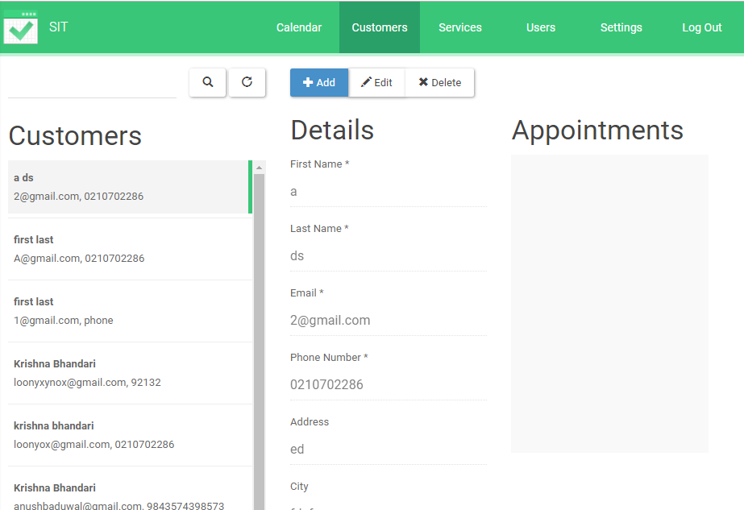

Select the customer you want to delete and click on delete.



A confirmation message will pop up click delete on the message and the customer will be deleted. If you don’t want to delete click on cancel.

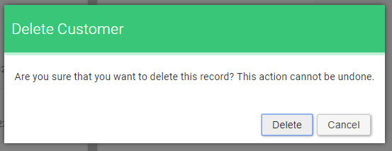

# How to delete any service?

Go to services from the main menu

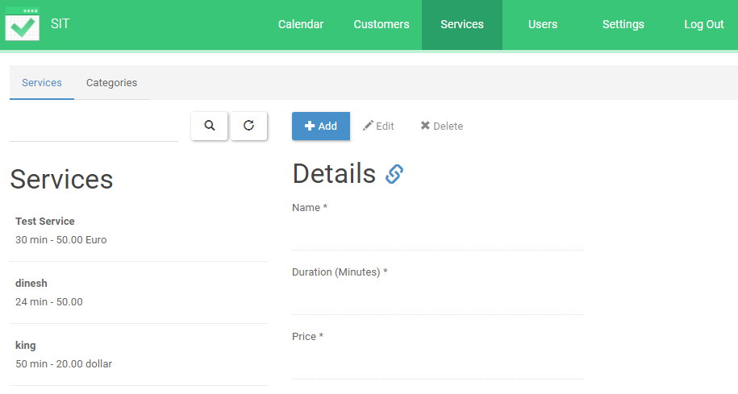

Select any service from the services.



After selecting the services click on delete.

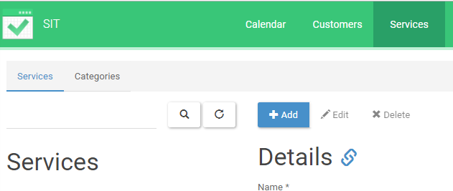

Again, a pop-up message will appear so if you want to delete click on delete.

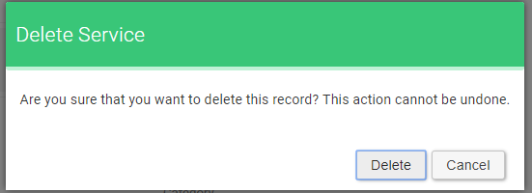

# How to delete user?

Go to users from the menu

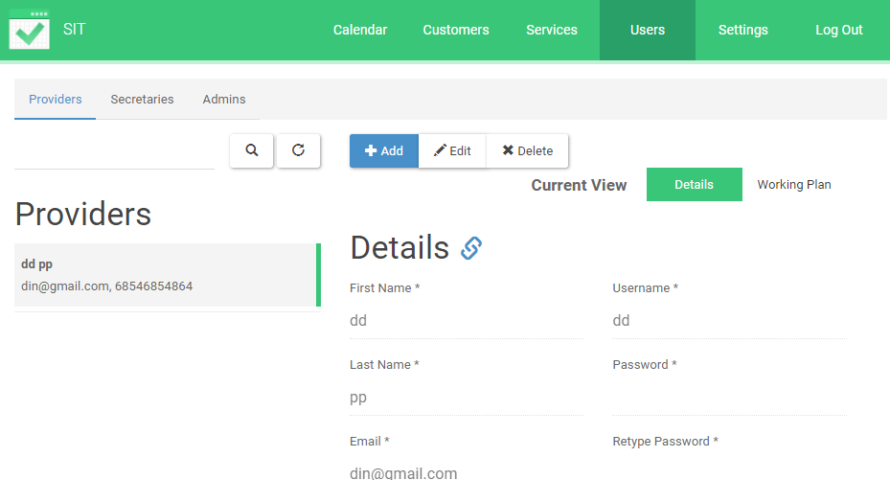

Select the user from providers and delete it.

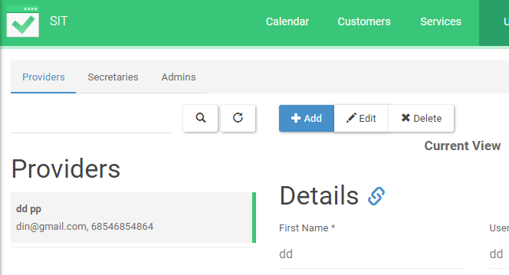

# How to add any unavailable day?

Go to calendar on the menu

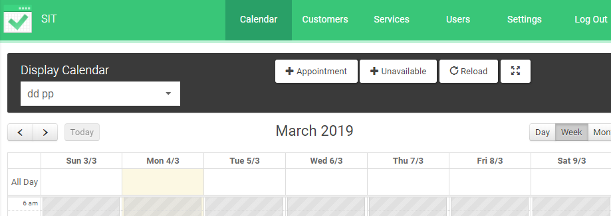

Click on un available



Chose the date till when you are going to be unavailable and save it

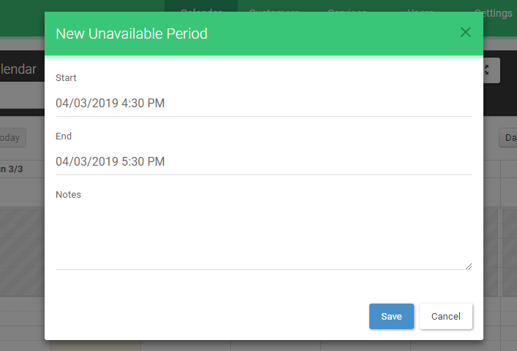

# How to add new admin?

Go to admins under users

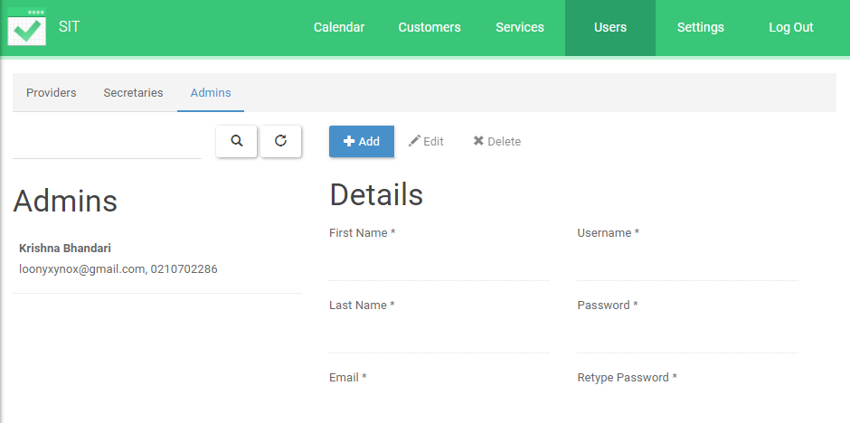

Click on add



Fill up the required information’s and save it.

# How to logout from backend section?

Click on log out from the main menu.

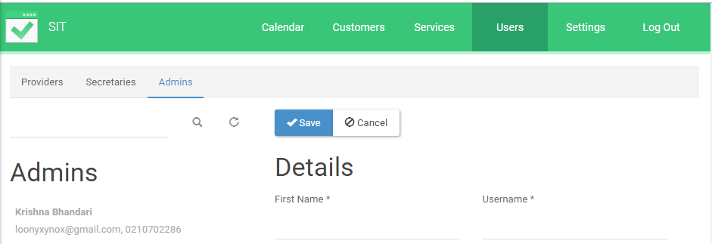

A popup message will appear on the screen.

